How to customize your wines for the spring and fall releases

- Go to cartographwines.com and click on the “Log in” button:
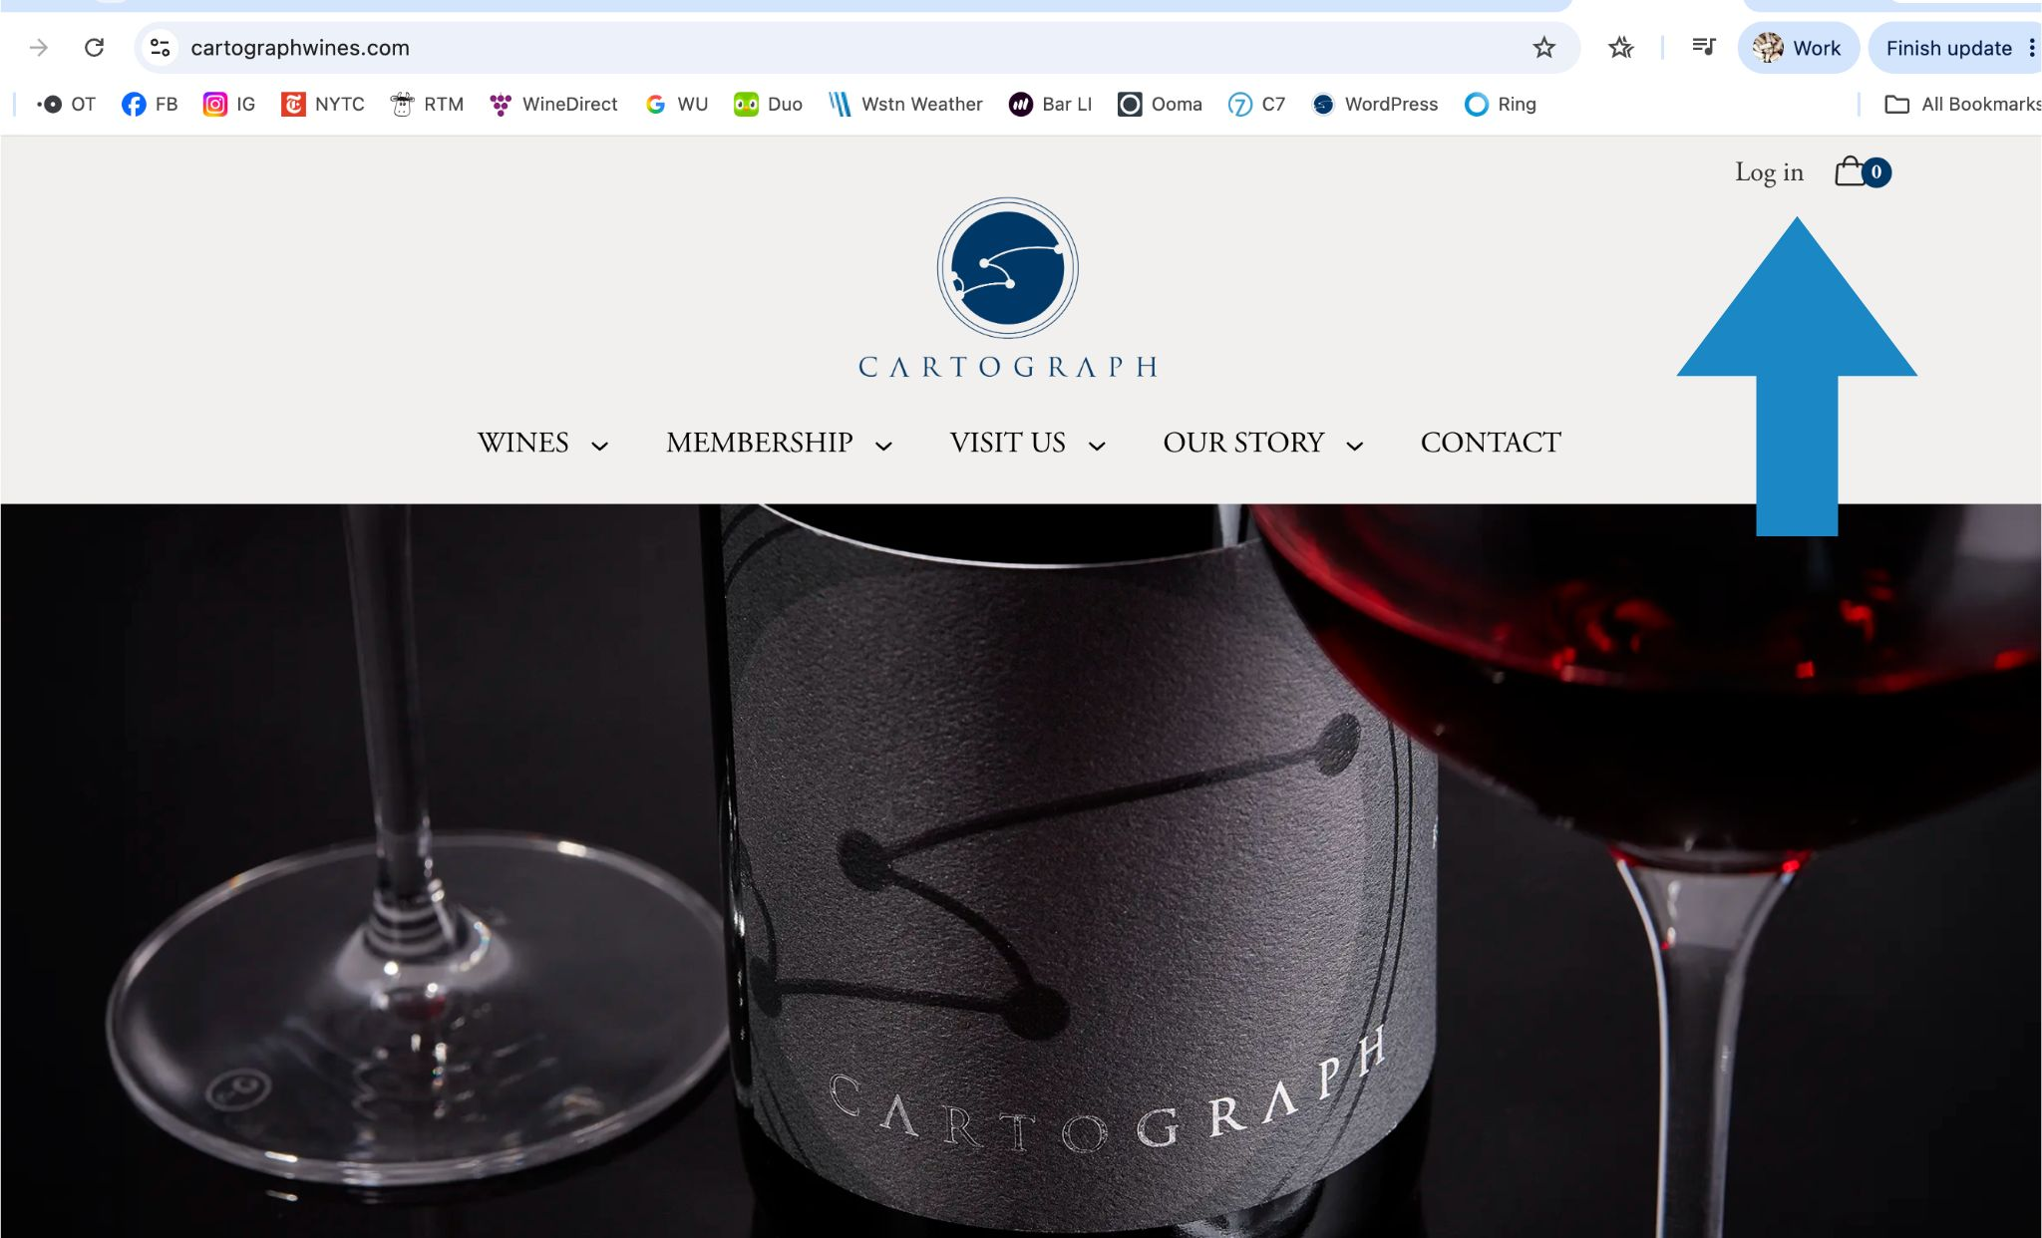

- You’ll see the new release on your dashboard once you have logged in. Click “View” to see all the wines available in the release.
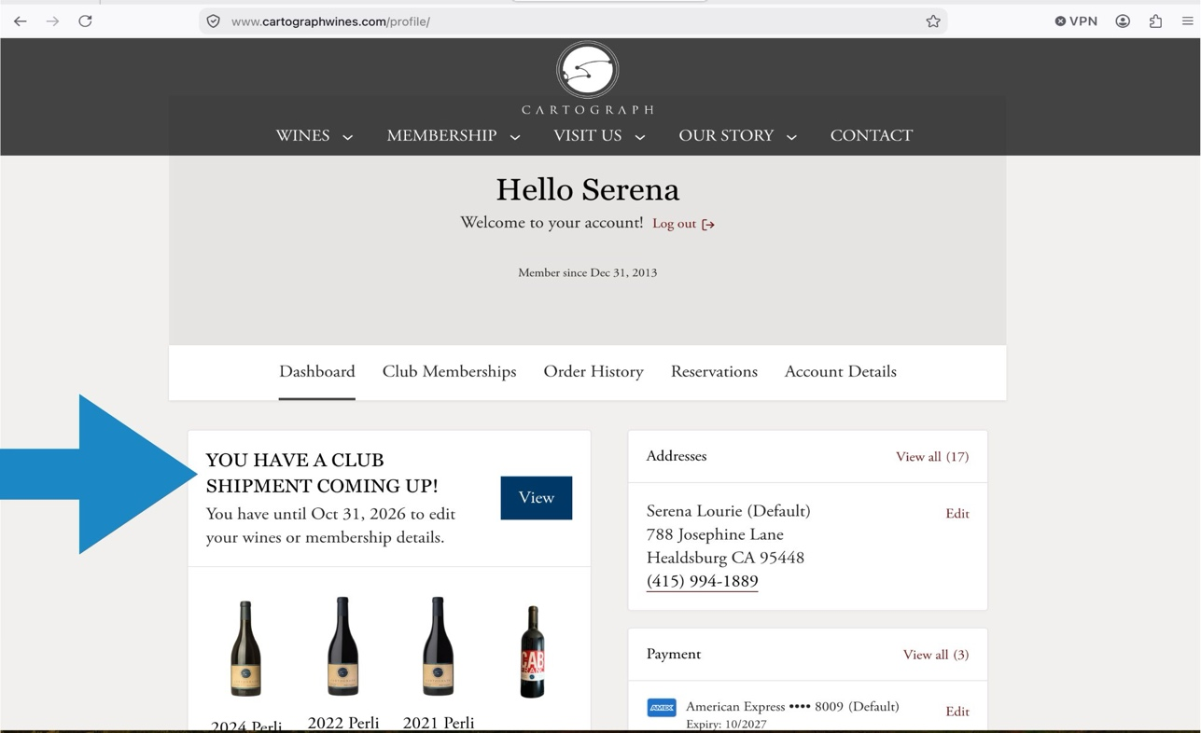

- After clicking “View”, you can edit your selection by clicking on “Edit Wines”
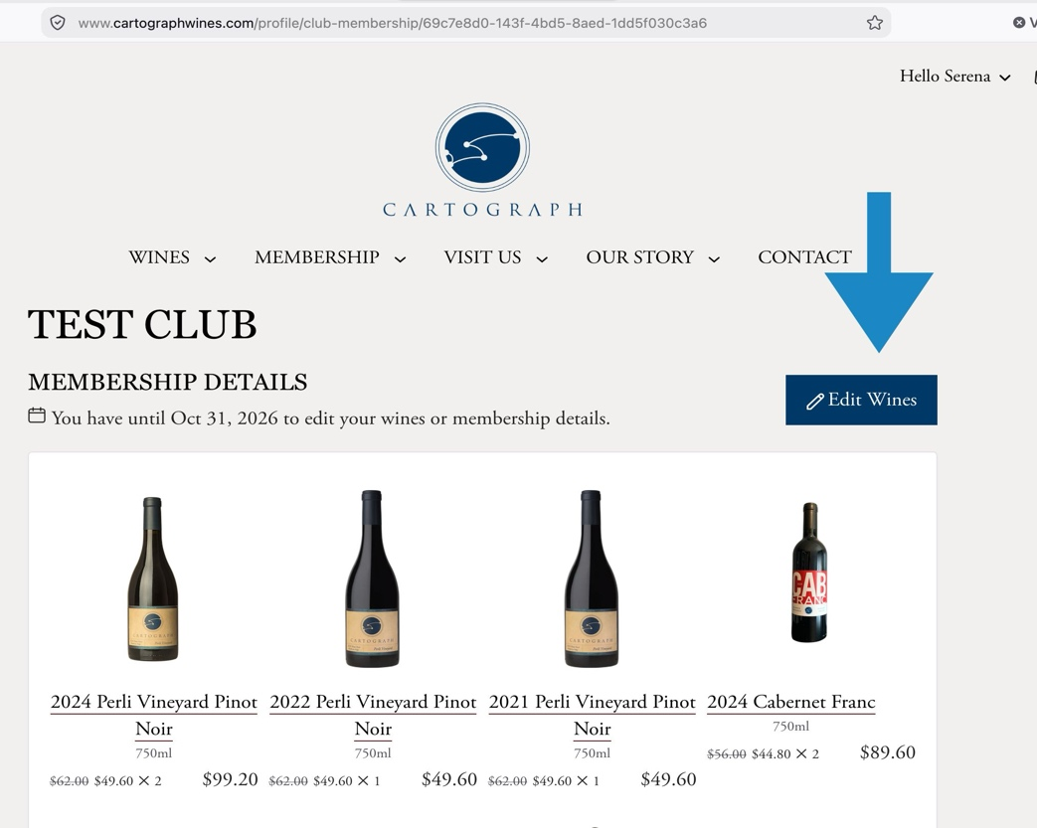
- Your shipment reflects the default winemaker’s selection. Please note that if a bottle is listed more than once, that is how the system shows you are receiving more than one bottle. If you like the winemaker’s selection, then there is nothing else to do. To see all the wines available to you (new wines and library wines), scroll down past the “Your Shipment” section to “Available wines” to customize your selection. Be sure to hit “Save Selection” after you make changes.
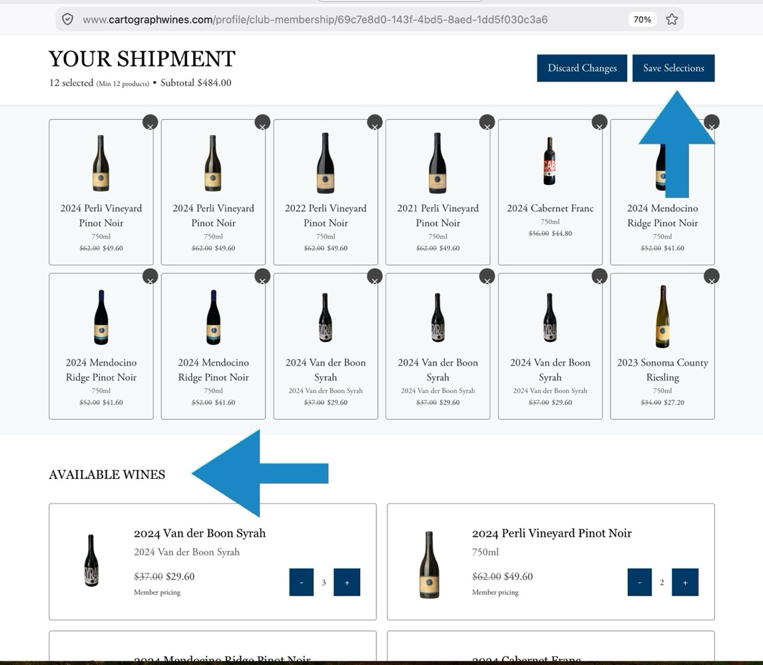

- If you need to update your address or credit card, please click on the “Club Membership” tab and you’ll be able to update your information.
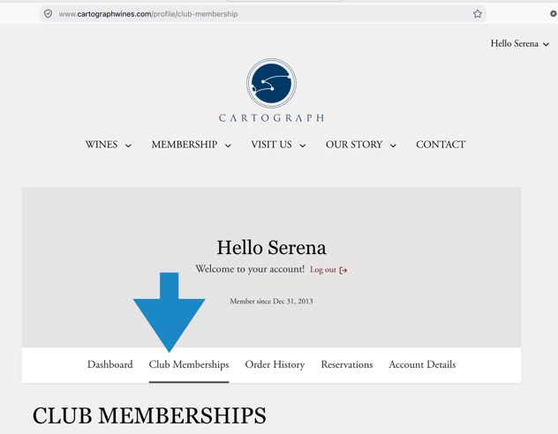

If you have any questions, please reach out by email or telephone. We are happy to help answer questions and navigate this system with you.

